**Experiment No: 10**

**Title:** Create custom app in salesforce lightning.

**Aim:** To understand the concepts of salesforce lightning and creating custom app by using it.

**Theory**:

**Salesforce Lightning:**

Lightning (Salesforce Lightning) is a [component](https://www.techtarget.com/whatis/definition/component)-based [framework](https://www.techtarget.com/whatis/definition/framework) for [Salesforce](https://www.techtarget.com/searchcustomerexperience/definition/Salesforcecom) [app](https://www.techtarget.com/searchmobilecomputing/definition/app) development. Salesforce Lightning aims to simplify the Salesforce app development processes for business users, who typically do not have programming experience.

Salesforce Lightning comprises a collection of tools and technologies behind a significant upgrade to the Salesforce1 Platform (now known as [App Cloud](https://www.techtarget.com/searchcustomerexperience/definition/Salesforce-App-Cloud)), the company's mobile app development platform ([MADP](https://www.techtarget.com/searchmobilecomputing/definition/mobile-application-development-platform)).

Lightning features the Lightning Component Framework and some Salesforce application development tools. These tools help developers build mobile apps with advanced Salesforce Lightning page layouts.

**Salesforce Lighting features:**

Here are some key Salesforce Lightning features:

* **Experience Builder** is a graphical user interface ([GUI](https://www.techtarget.com/whatis/definition/GUI-graphical-user-interface)) optimized for speed. Administrators can build robust communities using Lightning [templates](https://www.techtarget.com/whatis/definition/template) and components following a visual [no-code](https://www.techtarget.com/searchsoftwarequality/definition/no-code) development approach.
* **Lightning App Builder**follows a no-code development approach providing drag-and-drop capabilities to facilitate app creation and customization.
* **Lightning Component Framework** includes tools and extensions that enable the development of reusable components and standalone apps and Salesforce Mobile App customizations.
* **[AppExchange](https://www.techtarget.com/searchcustomerexperience/definition/Salesforce-AppExchange)** makes over 300 partner components available in the App Builder.
* **Design System** offers style guides and user experience ([UX](https://www.techtarget.com/searchcio/definition/UX-user-experience)) best practices for app development.
* **Lightning Connect** is an integration tool that makes it easier for Salesforce apps to consume data from any external source that conforms to the Open Data Protocol (OData)

Lightning developers can also build custom reusable components that other administrators and developers can incorporate into their Lightning Experience and Salesforce mobile apps.

**Salesforce Lightning benefits:**

* The activity timeline helps track the activity and history of each account or sales lead.
* The artificial intelligence ([AI](https://www.techtarget.com/searchenterpriseai/definition/AI-Artificial-Intelligence)) integration uses advanced protocols for [lead scoring](https://www.techtarget.com/searchcustomerexperience/definition/lead-scoring), opportunity scoring, and support for marketing resource assignment for the right customers or direct customer support.
* Expanded forecasting includes features like forecast sharing, [revenue and quantity forecasts](https://www.techtarget.com/searchcustomerexperience/definition/sales-forecast), territory forecasts, product and schedule date forecasts, and other customizable forecasts.
* There is greater [security](https://www.techtarget.com/searchsecurity/definition/security), with an additional security layer between the components and stronger [authentication](https://www.techtarget.com/searchsecurity/definition/authentication)
* A comprehensive homepage features news, key deals, events, calendars, performance charts and customizable [dashboards](https://www.techtarget.com/searchcio/definition/dashboard).
* Mobile optimization ensures optimal responsiveness across mobile devices and [browsers](https://www.techtarget.com/whatis/definition/browser).
* Workspace page layout lets users customize and design new types of pages

**Practical:**

Click on Lightning Experience and Click on Setup and select Setup for current App.

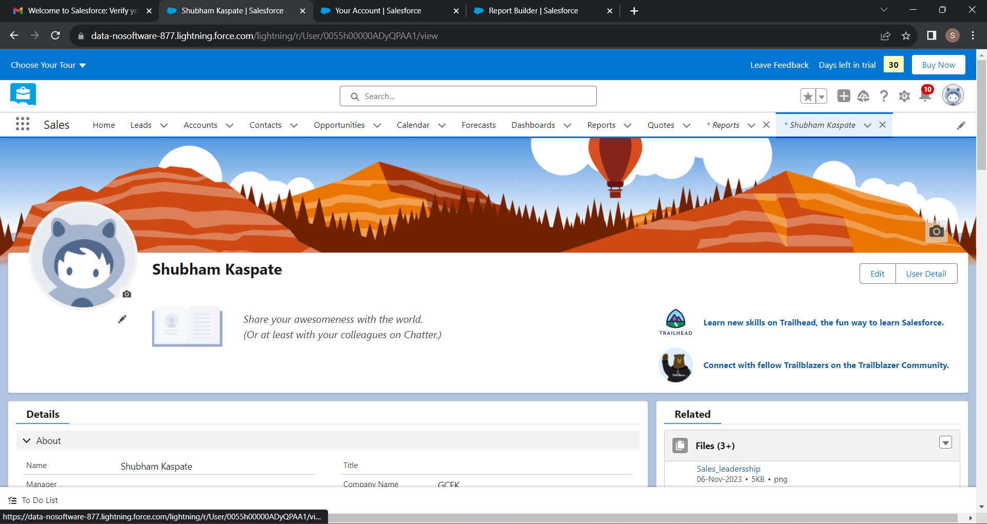

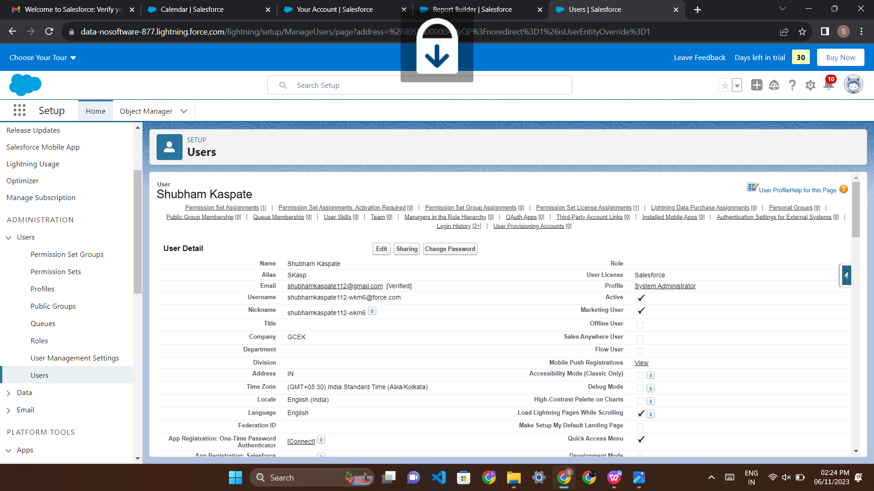

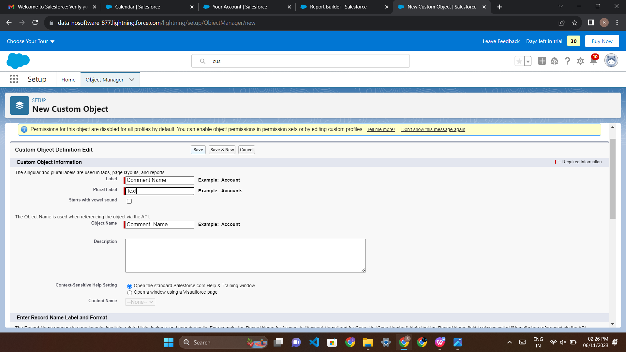

* Click on Create an Object So Click on Object Manager Tab next to Home Tab
* Click on Create –Custom Object
* New custom object page Open Label as a-Comment Plural label- comments
* Give Record Name as –comment name Data type- text Select Allow Reports Check Box Click on Save
* Click on Home-Search Tabs in Quick search Select Custom Object-Click on New

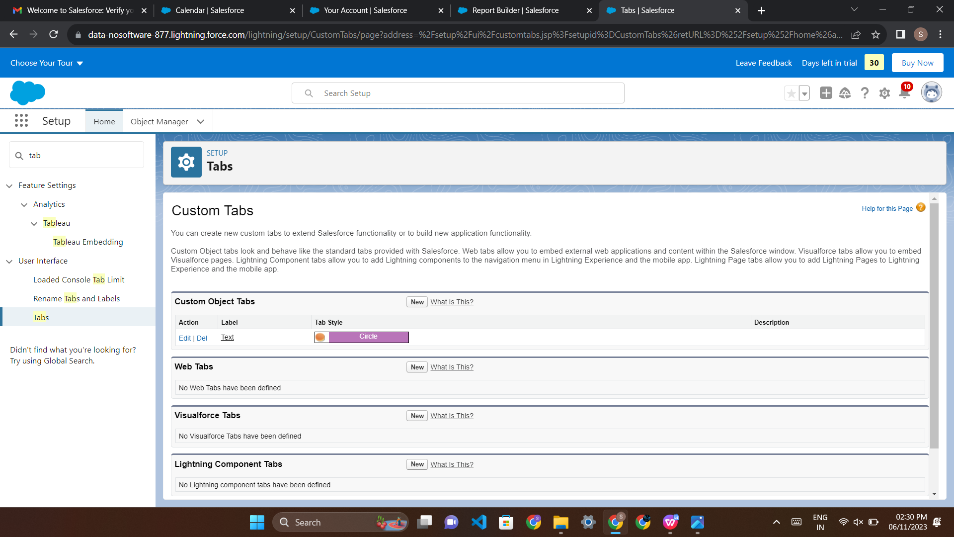

* For Object Select Comment For Tab Style Select Any Icon Click-Next-Next-Save and Search App Manager in Quick Search and select app manager

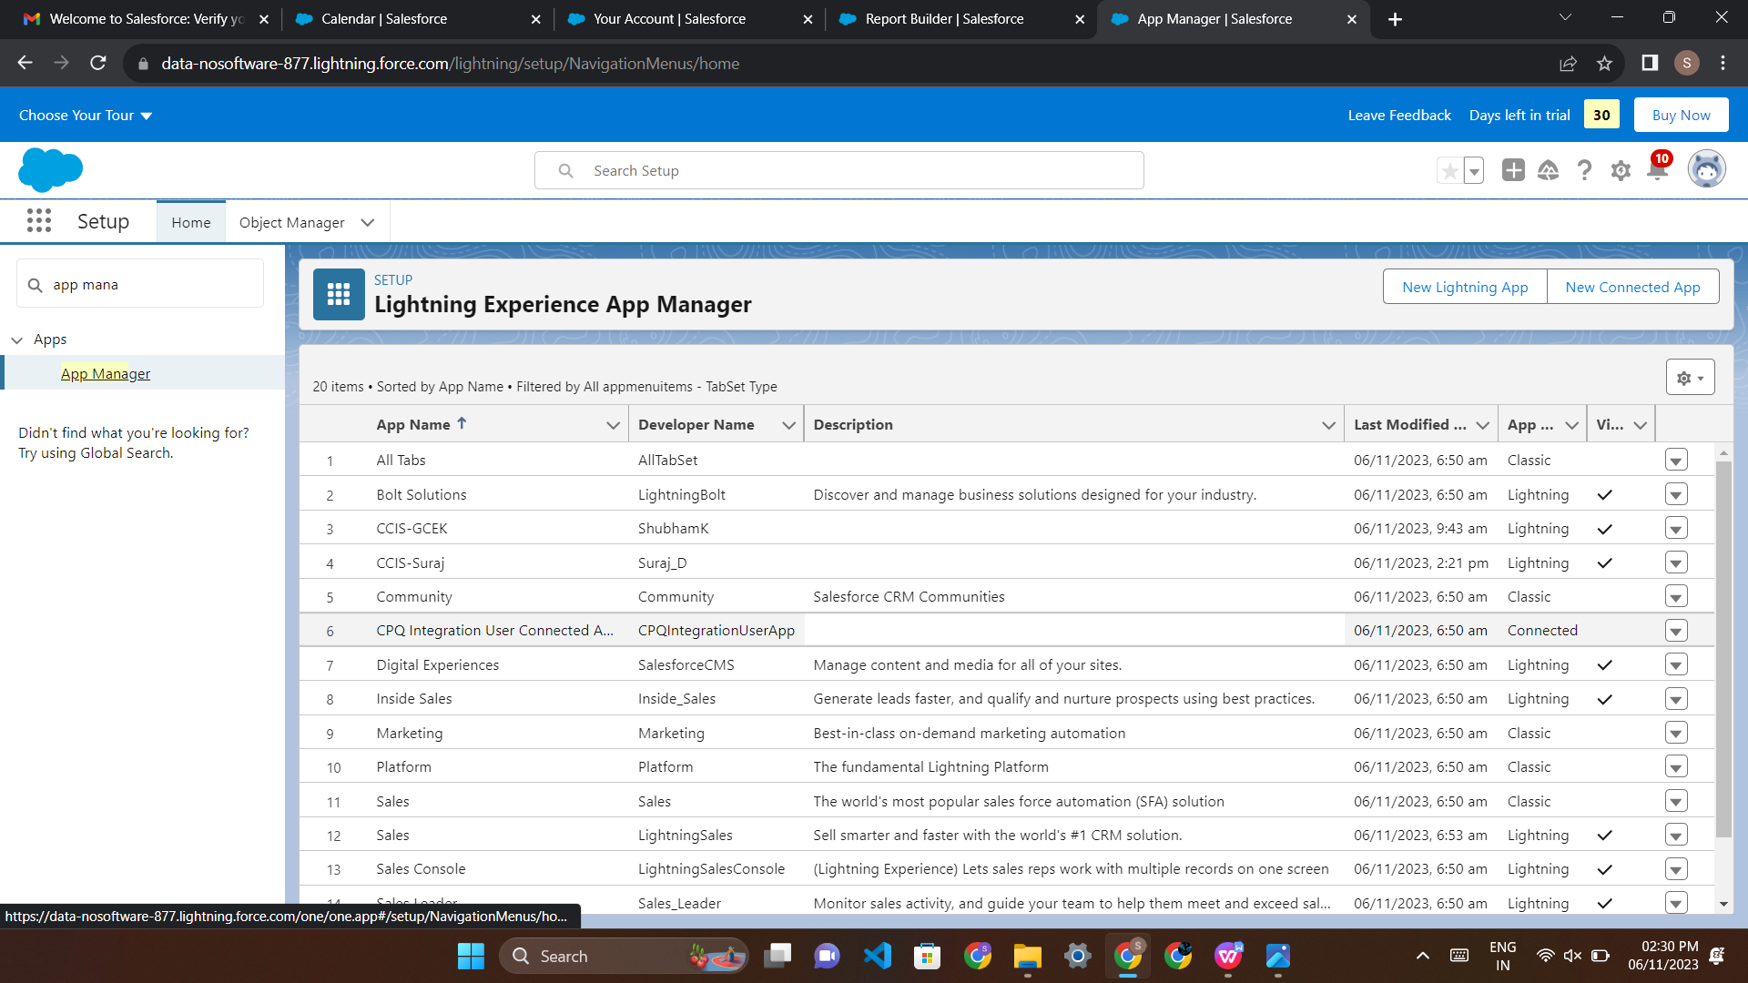

* Enter name to app name Click on Next-Next-Next. Select Items (Contacts, Comment) Click on Next

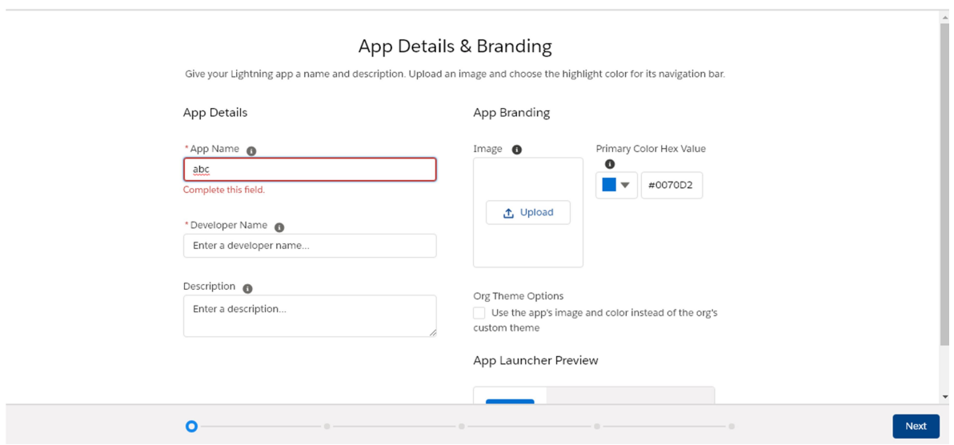

Step-9 Click on App Launcher Symbol and Select Comment Box App

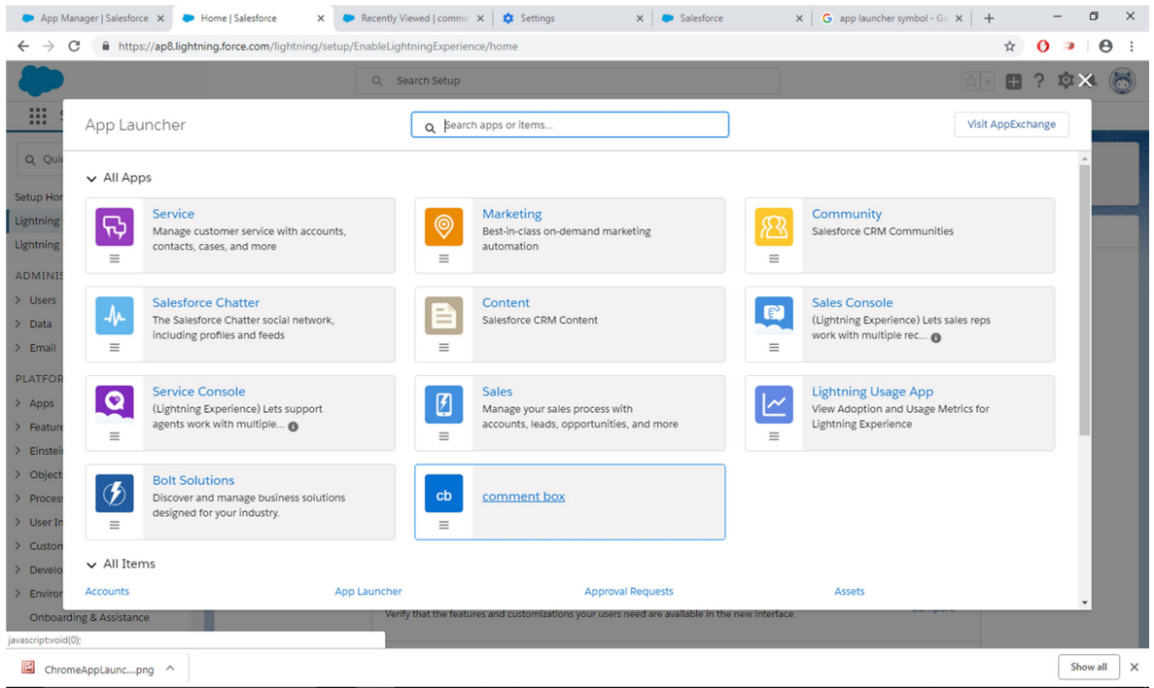

Try out mobile app -Select Chrome developer tools -Open Chrome-Right Click on Chrome page- Select Inspect -Click Toggle Device Mode Button to simulate your browser as a mobile device

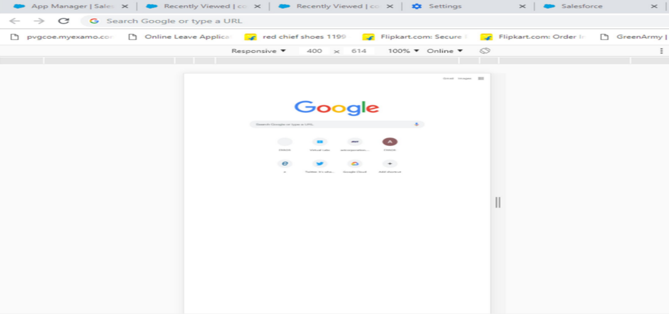

To simulate the sales force mobile app in your browser, copy and paste in url from previous tab. Delete the part of the url immediately. -Click on Left navigation bar -Find comment object under recent and click on it -Click new to create a comment

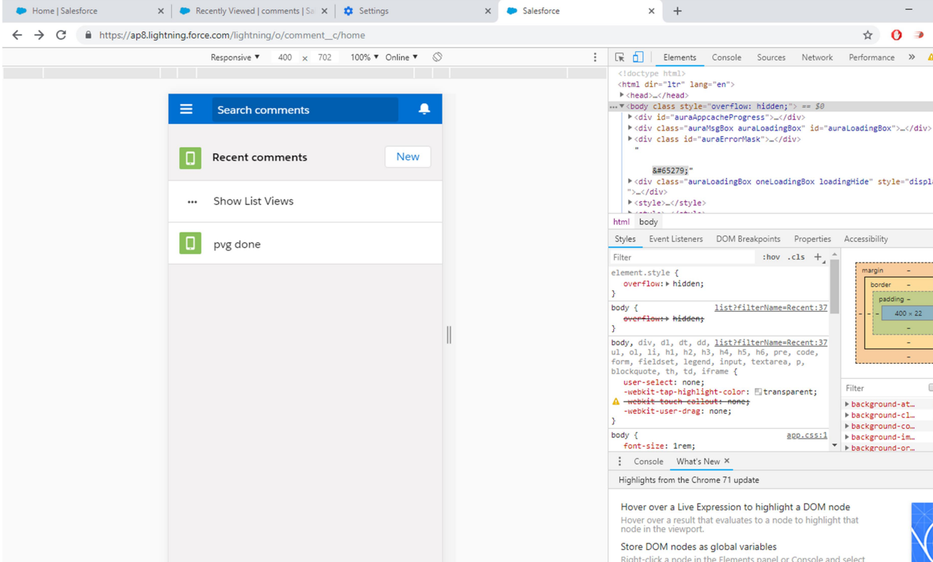

**Conclusion:** Thus, custom app in salesforce lightning created successfully.